PS-1603-X01 Firmware Spec

Revision | Date | Author | Comments
X01 | 12/Jan/2021 | Chen Wu Heng  Huang Shuang Cai | Initial version

PS-1603-X01 FIRMWARE SPEC 1
1. DIAGRAM 4
2. TARGET MICRO-P REQUIREMENT 4
3. GENERAL MICRO-P PINOUT DESCRIPTION 4
4. I/O PINS 6
4.1 INPUT PINS 6
4.2 OUTPUT PINS 6
5. ANALOG TO DIGITAL MEASUREMENT 8
6. PROTECTION 9
6.1 PROTECTION TIMING AND PMBUS FLAG 9
6.1.1 PAGE 0 9
6.1.2 PAGE 1 11
6.2 PROTECTION SETTING POINT 11
6.2.1 PROTECTION SETTING POINT FOR PMBUS CMD 11
6.2.2 UNIT_OFF POINT 12
6.3 PROTECTION RECOVER AND ALERT RECOVER DESCRIPTION 12
6.4 REPORTING UPDATE TIME 13
7. FLOWCHART 14
7.1 OVERVIEW 14
7.2 DETAIL STATUS DESCRIPTION 15
7.2.1 STATE_STANDBY 15
7.2.2 STATE_ONING 16
7.2.3 STATE_NORMAL 17
7.2.4 STATE_OFFING 18
7.2.5 STATE_LATCH 18
8. TIME SEQUENCE 19
8.1 NORMAL STATE TIME SEQUENCE 19
8.2 FAULT STATE TIME SEQUENCE -> AC_LOST 20
8.3 FAULT STATE TIME SEQUENCE -> PS_ON TO PS_OFF 21
8.4 FAULT STATE TIME SEQUENCE -> PS_OFF TO PS_ON 22
8.5 FAULT STATE TIME SEQUENCE -> NORMAL TO FAULT ( FAULT_FLAG: FAN LOCK, OVP, UVP, OCP, SCP, OTP, PRIIS, FAN_LOCK AND STB_OVP,STB_UVP) 23
9. OHERT CONTROL 24
9.1 PMBUS COMMUNICATION 24
9.2 BOOTLOADER 24
9.3 ALERT PIN AND MASK FUNCTION 24
9.4 FAN 25
9.5 LED DISPLAY 25
9.6 FW VERSION RULE 26
11. BLACK BOX FAULT LOGGING 28

Diagram
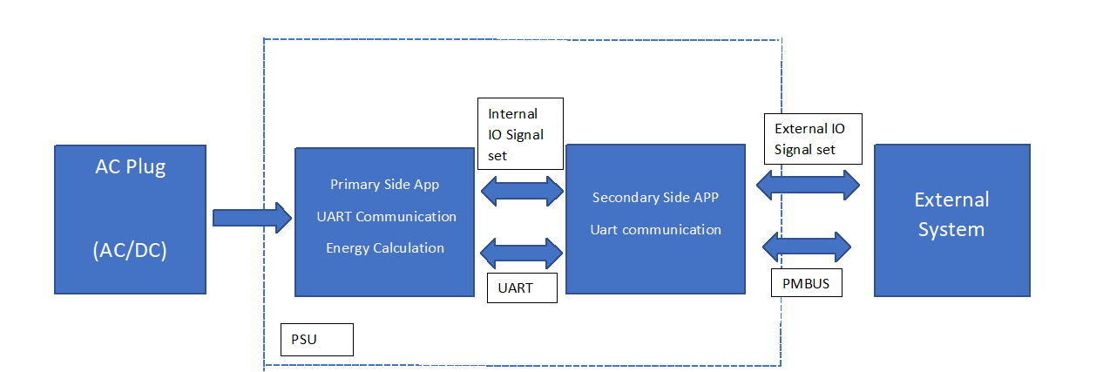

Internal IO Signal Set includes PFC_OK_SEC
External IO Signal Set includes ISHARE_DIS, PW_OK, PSON_EN

Target micro-P requirement
- Primary Microcontroller: Microchip DSPIC33EP32GS502
- Internal Crystal: 32KHz
- Speed : 70 MIPS
- Watchdog : Enable

Secondary Microcontroller: Microchip dsPIC33EP64GS504T -I/ML
- Internal Crystal: 32KHz
- Speed : 70 MIPS
- Watchdog : Enable

GENERAL MICRO-P PINOUT DESCRIPTION

Primary Pin assignment

Pin No | Pin Configuration | Pin Function | Pin Direction | PSU Signal / function | Details
1 | AN2 | Analog | Input | V_bulk | bulk vtg f/b
2 | AN3 | Analog | Input | I_PFC_MCU | PFC current for monitor and reporting
3 | AN4 | Analog | Input | T_PFC | Primary heatsink temperature
4 | AN5 | Analog | Input | VDC_MCU | Vbulk_sense
5 | Vss
6 | RB1 | GPIO | Output | PFC_OK_PRI( to sec) | AC OK signal to sec MCU
7 | RB2 | GPIO | Output | AC_OK_PRI ( to sec) | PFC OK signal to sec MCU
8 | RP35 | Uart | Input | PRI_RX | Communication with secondary MCU
9 | RP36 | Uart | Output | PRI_TX | Communication with secondary MCU
10 | VDD
11 | RB8 | GPIO | Input | TP | TEST_POINT
12 | RB15 | GPIO | Output | LED1
13 | RB5 | GPIO | Output | DEBUG | DEBUG
14 | PGED1 | Programming
15 | PGEC1 | Programming
16 | Vss
17 | Vcap
22 | PWM1H/RA4 | PWM/GPIO | Output | Relay CTRL | Inrush Relay signal
23 | RA3 | GPIO | Output | PFC_ON_H | Enable PFC Signal
24 | AVss
25 | AVDD
26 | MCLR |  |  | MCLR_PRI
27 | AN0 | Analog | Input | Vin_L | Input line voltage
28 | AN1 | Analog | Input | Vin_N | Input neutral vtg

Secondary MCU pin assignment

Pin No | Pin Configuration | Pin Function | Pin Direction | PSU Signal / function | Details
1 | PGEC1 | programming |  |  | programming
2 | RC4 | GPIO | Input | PS_A1 | address Select
3 | RC5 | GPIO | Input | PS_A2 | address Select
4 | RC6 | GPIO | Input | PFC_OK_SEC | pfc status
5 | RC3 | GPIO | Input | PS_A0 | address Select
6 | Vss
7 | Vcap
8 | RB11 | GPIO | Output | ORING_EN_MCU | ORing gate signal
9 | RB12 | GPIO | Output | POK | pok
10 | PWM2H | PWM | Output | 12V_SOFT_TRIM | 12V software trimming
11 | RB14 | GPIO | Input | FAN_SPEED | Measure FAN RPM
12 | PWM1H | PWM | Output | FAN_PWM | PWM control for FAN
13 | RA3 | GPIO | Input | PSON / REMOTE ON | ps on/off
14 | RC0 | GPIO | Input | AC_OK_SEC | ac ok signal from primary
15 | RC13 | GPIO | Output | LLC_DIS | LLC primary gate driver disable
16 | AVss
17 | AVDD
18 | MCLR
19 | RC11 | GPIO | Output | STB_ORING_EN_MCU | ENABLE STANDBY ORING
20 | RC12 | GPIO | Output | SR_EN_MCU | ENABLE SR
21 | AN0 | Analog | Input | 12V_ORING_MCU | output voltage before ORing
22 | AN1 | Analog | Input | I_OUT_MCU | PSU output current
23 | AN2 | Analog | Input | 12V_OUT_MCU | PSU output voltage
24 | AN3 | Analog | Input | ISHARE_INT | current share internal voltage
25 | AN4 | Analog | Input | STB_5V_OUT_MCU | 5V SB Voltage sense
26 | AN5 | Analog | Input | STB_I_OUT_MCU | standby current sense
27 | RP57 | UART | Input | SEC_RX | communication with primary MCU
28 | RP58 | UART | Output | SEC_TX | communication with primary MCU
29 | VDD
30 | Vss
31 | RC1 | GPIO | Output | 12V_DROOP | output pwm
32 | AN6 | Analog | Input | CS_OUT_READ | Input ADC, for current share
33 | AN7 | Analog | Input | T_SR_MCU | SR heatsink temp sensing
34 | DACOUT1 | Analog | Ouput | DAC_OUT | DAC_OUT for current share
35 | RB4 | GPIO | Input | ISHARE_DIS | Current share disable
37 | ASDA1 | I2C | In/Out | PMBUS_SDA | Pmbus data line
38 | ASCL1 | I2C | Output | PMBUS_SCL | Pmbus clock line
39
40
41 | SDA2 |  |  |  | EEPROM
42 | SCL2 |  |  |  | EEPROM
43 | RB5 | GPIO | Output | LED1 | Status LED
44 | PGED1 | programming |  |  | programming

I/O PINS

Primary Side

OutPut PIN
Pin # | Pin name | Initial State | Connect to | I/O Level definition
6 | RB1 | L | PFC_OK_PRI | Logic 0 : PFC OK  Logic 1 : PFC Not OK
7 | RB2 | H | AC_OK_PRI | Logic 0 : AC OK  Logic 1 : AC Not OK
22 | RA4 | H | Inrush Relay CTRL | Logic 0: ON  Logic 1: OFF
23 | RA3 | L | PFC_ON | Logic 0 : Disable  Logic 1 : Enable

ANALOG TO DIGITAL MEASUREMENT
Pin # | Pin Name | Connect to | Scale
1 | AN2 | V_bulk | 0Vi/0V ~ 560Vi/3.3V
2 | AN3 | I_PFC_MCU | 0Vac/0V ~ 100Vac/3.3V
3 | AN4 | T_PRI | ? 10K NTC
27 | AN0 | Vin_L | 0Vac/0V ~ 509Vac/3.3V
28 | AN1 | Vin_N | 0Vac/0V ~ 509Vac/3.3V

Secondary Side

Input pins

Pin # | Pin name | Connect to | I/O Level definition
2 | RC4 | PS_A1 | Logic 0: I2C address value for zero  Logic 1: I2C address value for one
3 | RC5 | PS_A2 | Logic 0: I2C address value for zero  Logic 1: I2C address value for one
4 | RC6 | PFC_OK_SEC | Logic 0: PFC OK  Logic 1: PFC NOT OK
5 | RC3 | PS_A0 | Logic 0: I2C address value for zero  Logic 1: I2C address value for one
13 | RB5 | PSON | Logic 0: PS_OFF  Logic 1: PS_ON
14 | RA3 | AC_OK__SEC | Logic 0: AC GOOD  Logic 1:AC NOT GOOD

4.2.2 OUTput pins
Pin # | Pin name | Initial State | Connect to | I/O Level definition
8 | RB11 | L | ORINF_EN_MCU | Logic 0: Oring disable  Logic 1: Oring enable
9 | RB12 | L | PW_GOOD | Logic 0: Power not Good  Logic 1: Power Good
15 | RC13 | L | LLC_DIS | Logic 0: LLC IC disable  Logic 1: LLC IC enable
43 | RB5 | L | LED1 | Logic 0: No AC power available  Blinking: AC Present / +5VSB on  (Main DC Output OFF)  Logic 1: Power Supply ON and OK
19 | RC11 | L | STB_ORING_EN_MCU | Logic 0: standby oring disable  Logic 1: standby oring enable
20 | RC12 | L | SR_EN_MCU | Logic 0: SR disable  Logic 1: SR enable
36 | RC2 | L | FAN_CNTRL | Logic 0: FAN disable  Logic 1: FAN enable
35 | RB4 | L | ISHARE_DIS | Logic 0: Disable current sharing  Logic 1: Enable current sharing

ANALOGUE
Pin # | Pin Name | Connect to | Scale
21 | AN0 | 12V_ORING_MCU | 0V/0Vdc ~ 16.23V/3.3Vdc
22 | AN1 | I_OUT_MCU | 0A/0V ~ ? 60A/3.3V
23 | AN2 | 12V_OUT_MCU | 0V/0Vdc ~ 16.23V/3.3Vdc
24 | AN3 | ISHARE_IN | 0A/0V ~ ? 10.584V/3.3V
25 | AN4 | STB_5V_OUT_MCU | 0A/0V ~ 6V/3.3V
26 | AN5 | STB_I_OUT_MCU | 0A/0V ~ 0.5A/3.3V
32 | AN6 | CS_OUT_READ | 0A/0V ~ ? A/3.3V
33 | AN7 | T_SR_MCU | 10K NTC
34 | DACOUT1 | DAC_OUT
- Resolution: 12-bits, reference voltage 3.3V.

5. A/D Detection Method

AC input

AC Slow-Speed detection
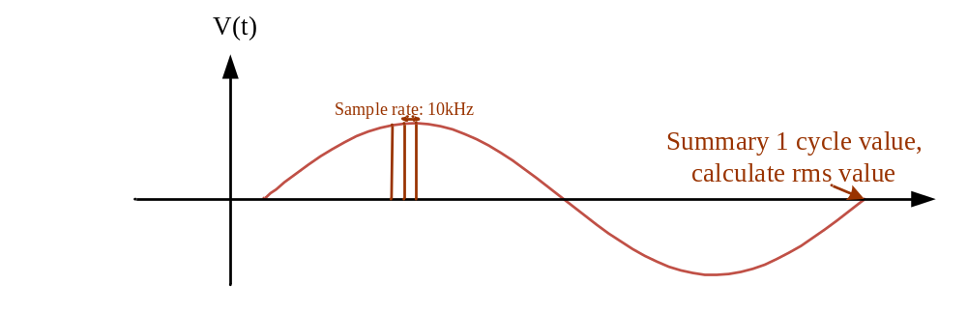
- x₁、x₂... x_{n} are sampling points in one period of input AC source and captured in the fixed rate (sampling frequency fs is 10kHz )
- Estimated voltage in Peak value is calculated by Vin.

DC INPUT
- Digital filter, Sample rate: ? 2kHz
- PFC bus low pass filter: ? 100Hz

PFC output
- Digital filter, Sample rate: ? 2kHz
- PFC bus low pass filter: ? 100Hz

PROTECTION

PFC Protection

BUS Voltage
Bus Detection | FW Delay Time | Value | Protect
PFC Bus voltage – OVP - Low | 120ms | 450v | Disable PFC_OK, PFC disable ,Latch PFC
PFC Bus voltage – OVP - High | 2ms | 460v | Disable PFC_OK, PFC disable ,Latch PFC
PFC Bus voltage – UVP - Drop | 1ms | 335/330v | Disable PFC_OK, PFC off and delay to restart

OTP
Temp Detection | Delay time | Value | Recovery Value | Protect
PFC Over temp | 10s | 110C | 60C | Disable PFC_OK, Latch

Input Voltage
Input Detection | Delay time | Value | Recovery Value | Protect
Vin OVP - AC | 72ms | 295V | 264V | PFC Relay Turn off, PFC not OK, PFC disable. PFC off ,after delay auto restart
Vin UVP - AC | 2ms | 75V | 85V | PFC Relay Turn off, PFC not OK, PFC disable. PFC off ,after delay auto restart
Vin OVP - DC | 72ms | 310V | 288V | PFC Relay Turn off, PFC not OK, PFC disable. PFC off ,after delay auto restart
Vin UVP - DC | 2ms | 110V | 125V | PFC Relay Turn off, PFC not OK, PFC disable. PFC off ,after delay auto restart
- PFC Recovery time please ref. to 8. PFC START TIME SEQUENCE

PROTECTION

Protection Timing and PMbus Flag

Page 0
Event | 12V main output shut down once trigger | 12V Can Auto recovery once the condition return to normal | 79H |  | 7AH | 7BH | 7CH | 7DH | 7EH | 81H | Event trigger --> Bit assert (unmask) | Event trigger --> SMBAlert assert (unmask) | Event trigger --> PSU shut down
12V OVW | NO | YES | 8000 |  | 40 | 00 | 00 | 00 | 00 | 00 | 20us | 20us
12V OVP | YES | NO | 8860 |  | C0 | 00 | 00 | 00 | 00 | 00 | 40us | 40us | 45us
12V OCW | NO | YES | 4000 |  | 00 | 20 | 00 | 00 | 00 | 00 | 800ms | 800ms
12V OCP | YES | NO | 4850 |  | 00 | A0 | 00 | 00 | 00 | 00 | 1.2 s | 1.2 s | 1.2 s
12V SCP  (Output SCP) | YES | NO | 4850 |  | 00 | A0 | 00 | 00 | 00 | 00 | 20 us | 20 us | 20 us
12V UVW | NO | YES | 8000 |  | 20 | 00 | 00 | 00 | 00 | 00 | main loop immediately | main loop immediately
12V UVP | YES | NO | 8840 |  | 30 | 00 | 00 | 00 | 00 | 00 | 1.2 s | 1.2 s | 1.2 s
OTW 2  (1nd hot-spot) | NO | YES | 0004 |  | 00 | 00 | 00 | 40 | 00 | 00 | 1 s | 1 s
OTP2  (1nd hot-spot) | YES | YES | 0844 |  | 00 | 00 | 00 | C0 | 00 | 00 | 5 s | 5 s | 5 s
OTW3  (2nd hot-spot) | NO | YES | 0004 |  | 00 | 00 | 00 | 40 | 00 | 00 | 1 s | 1 s
OTP3  (2nd hot-spot) | YES | YES | 0844 |  | 00 | 00 | 00 | C0 | 00 | 00 | 5 s | 5 s | 5 s
FAN FAULT | YES | NO | 0C40 |  | 00 | 00 | 00 | 00 | 00 | 80 | 15 s | 15 s | 15 s
FAN Override | NO | YES | 0000 |  | 00 | 00 | 00 | 00 | 00 | 08 | 1s | 1s | 1s
Standby Fault  (5Vstb OVP) | YES | YES | 0840 |  | 00 | 00 | 00 | 00 | 00 | 00
Standby Fault  (5Vstb UVP) | YES | YES | 0840 |  | 00 | 00 | 00 | 00 | 00 | 00
Standby Fault  (5Vstb SCP) | YES | YES | 0840 |  | 00 | 00 | 00 | 00 | 00 | 00
Standby Fault  (5Vstb OCP) | YES | YES | 0840 |  | 00 | 00 | 00 | 00 | 00 | 00
AC INPUT UVW | NO | YES | 2000 |  | 00 | 00 | 20 | 00 | 00 | 00 | 0.5~ 0.6 sec | 0.5~ 0.6 sec
AC INPUT UVP | YES | YES | 2848 |  | 00 | 00 | 30 | 00 | 00 | 00 | 0.5~ 0.6 sec | 0.5~ 0.6 sec | 0.5~ 0.6 sec
AC INPUT UVP  (UNIT_OFF) | YES | YES | 2848 |  | 00 | 00 | 38 | 00 | 00 | 00 | 0.5~ 0.6 sec | 0.5~ 0.6 sec | 0.5~ 0.6 sec
AC INPUT OVP | YES | YES | 2840 |  | 00 | 00 | C0 | 00 | 00 | 00 | 4~6 AC cycle | 4~6 AC cycle | 4~6 AC cycle
AC INPUT OVP  (UNIT_OFF) | YES | YES | 2840 |  | 00 | 00 | C8 | 00 | 00 | 00 | 4~6 AC cycle | 4~6 AC cycle | 4~6 AC cycle
AC INPUT OVW | NO | YES | 2000 |  | 00 | 00 | 40 | 00 | 00 | 00 | 4~6 AC cycle | 4 ~6AC cycle
Switch Component Fault | - | - | 0200 |  | 00 | 00 | 00 | 00 | 00 | 00 | - | - | -
- AC INPUT is depended on Meter IC average time and transmit time, so it has some tolerance.
- Switch Component Fault: If Vin1 and Vin2 all in normal range, Component Open still can remain 12V main output. Component short will disable 12V main output¸ detail description refer to Primary firmware specification.

Page 1
Event | 12V main output shut down once trigger | LED | 12V Can Auto recovery once the condition return to normal | 79H | 7AH | 7BH | 7CH | 7DH | 7EH | 81H | Event trigger --> Bit assert (unmask) | Event trigger --> SMBAlert assert (unmask) | Event trigger --> PSU shut down
OTW 1  (Ambient) | NO | BLINK GREEN | YES | 0004 | 00 | 00 | 00 | 40 | 00 | N/A | 1 s | 1 s
OTP1  (Ambient) | YES | SOLID AMBER | YES | 0844 | 00 | 00 | 00 | C0 | 00 | N/A | 5 s | 5 s | 5 s
Standby Fault  (5Vstb OVP) | YES | SOLID AMBER | YES | 8860 | C0 | 00 | 00 | 00 | 00 | N/A | 20us | 20us | 20us
Standby Fault  (5Vstb UVP) | YES | SOLID AMBER | YES | 8840 | 30 | 00 | 00 | 00 | 00 | N/A | 120 ms | 120 ms | 120 ms
Standby Fault  (5Vstb SCP) | YES | SOLID AMBER | YES | 4850 | 00 | 80 | 00 | 00 | 00 | N/A | 20us | 20us | 20us
Standby Fault  (5Vstb OCP) | YES | SOLID AMBER | YES | 4850 | 00 | 80 | 00 | 00 | 00 | N/A | 120 ms | 120 ms | 120 ms

Protection Setting Point

Protection Setting Point For PMBus CMD
Command code | Warning & Fault | FW default value | HW default value
0x58 (VIN_UV_WARN_LIMIT) | Vin_UV_warning | AC:173 Vac | N/A
0x59 (VIN_UV_FAULT_LIMIT) | Vin UV fault | AC: 170 Vac | N/A
 | Vin_UV_fault Recovery | AC: 175Vac | N/A
0x57 (VIN_OV_WARN_LIMIT) | Vin_OV_warning | AC:275 Vac | N/A
0x55 (VIN_OV_FAULT_LIMIT) | Vin_OV_fault | AC: 285 Vac | N/A
 | Vin_OV_fault recovery | AC: 272 Vac | N/A
0x42 (VOUT_OV_WARN_LIMIT) | Vout OV Warning | DC: 13.2 V | N/A
0x40 (VOUT_OV_FAULT_LIMIT) | Vout OV FAULT | DC: 13.5 V | N/A
0x43 (VOUT_UV_WARN_LIMIT) | Vout UV Warning | DC: 11.5 V | N/A
0x44 (VOUT_UV_FAULT_LIMIT) | Vout UV Fault | DC: 10.5 V | N/A
0x4A (IOUT_OC_WARN_LIMIT) | Iout OC warning | DC: 210A | N/A
0x46 (IOUT_OC_FAULT_LIMIT) | Iout OC fault | DC: 220A | N/A
 | Constant Current Limit | N/A | 240A
 | VOUT SCP | DC: 270A | N/A
 | 12VSB OVP | DC: 14.2 | DC: 14.7 V
 | 12VSB OVW | DC: 13.5 | N/A
 | 12VSB UVP | DC: 10.7 | N/A
 | 12VSB OCP | DC: 3.5 A | N/A
 | 12VSB OCW | DC: 3.0A | N/A
 | 12VSB SCP | DC: 5.5A | DC: 6.3A
0x51 (OT_WARN_LIMIT, PAGE1) | OT warning (Ambient) | Ambient OT warning: 55 C | N/A
0x51 (OT_WARN_LIMIT, PAGE0) | OT warning (Hotspot) | Hotspot OT warning: 100 C | N/A
0x4F (OT_FAULT_LIMIT, PAGE1) | OTP (Ambient) | Ambient OT Fault: 67 C | N/A
0x4F (OT_FAULT_LIMIT, PAGE0) | OTP (Hotspot) | Hotspot OT warning: 110 C | N/A
 | OTP recovery (Ambient) | Ambient OT Recovery: 52 C | N/A
 | OTP recovery (Hotspot) | Hotspot OT Recovery: 80 C | N/A
 | Fan Fault | FAN RPM < 500 RPM, | N/A

UNIT_OFF Point
Recovery point same as Vin_UV_fault and Vin_OV_fault recovery point.
Status_Input (7CH) | FW default value
UNIT_OFF (UV) | AC:165 Vac
UNIT_OFF (OV) | AC: 295 Vac

Protection Recover and Alert Recover Description
Event | Recovery  Method | After Recovery,  12V turn on time
12V OVW | Clear Fault(0x03), PS_ON_OFF | -
12V OVP | PS_ON_OFF | Follow PS_ON_OFF startup time
12V OCW | Clear Fault(0x03), PS_ON_OFF | -
12V OCP | PS_ON_OFF | Follow PS_ON_OFF startup time
12V SCP  (Output SCP) | PS_ON_OFF | Follow PS_ON_OFF startup time
12V UVW | Clear Fault(0x03), PS_ON_OFF | -
12V UVP | PS_ON_OFF | Follow PS_ON_OFF startup time
OTW 1  (Ambient) | Clear Fault(0x03), PS_ON_OFF | -
OTP1  (Ambient) | Back to recover temp, but  Fault flag clear only by Clear Fault(0x03) | 3 sec
OTW2  (2nd hot-spot) | Clear Fault(0x03), PS_ON_OFF | -
OTP2  (2nd hot-spot) | Back to recover temp, but  Fault flag clear only by Clear Fault(0x03) | 3 sec
FAN FAULT | PS_ON_OFF | Follow PS_ON_OFF startup time
Standby Fault  (5Vstb OVP) | Back to recover voltage | until fault clear, every 5sec retry.
Standby Fault  (5Vstb UVP) | Back to recover voltage | until fault clear, every 5sec retry.
Standby Fault  (5Vstb SCP) | Fault event remove | until fault clear, every 5sec retry.
Standby Fault  (5Vstb OCP) | Back to recover current | until fault clear, every 5sec retry.
AC INPUT UVW | Clear Fault(0x03), PS_ON_OFF | -
AC INPUT UVP | Back to recovery voltage | 0.4s~0.9s
AC INPUT OVP | Back to fault recovery voltage | 0.4s~0.9s
AC INPUT OVW | Clear Fault(0x03), PS_ON_OFF | -
Switch Component Fault | Aux power restart and Component fixed | -

Reporting Update Time
Report Item | Update Time (s) | Accuracy (%)
Vin | 20 ms | +/-5%
Iin | 640 ms | +/-5%
Pin | 160 ms | +/-5%
Vout | 10.24 ms | +/-5%v
Iout | 163.84 ms | +/-5%
Pout | 163.84 ms | +/-5%
Tinlet | 640 us | +/-5°C
Tpri | 250 ms | +/-5°C
Tsec | 640 us | +/-5°C
Fan | Updated every cycle | +/-5%

FLOWCHART

Primary flowchart OVERVIEW
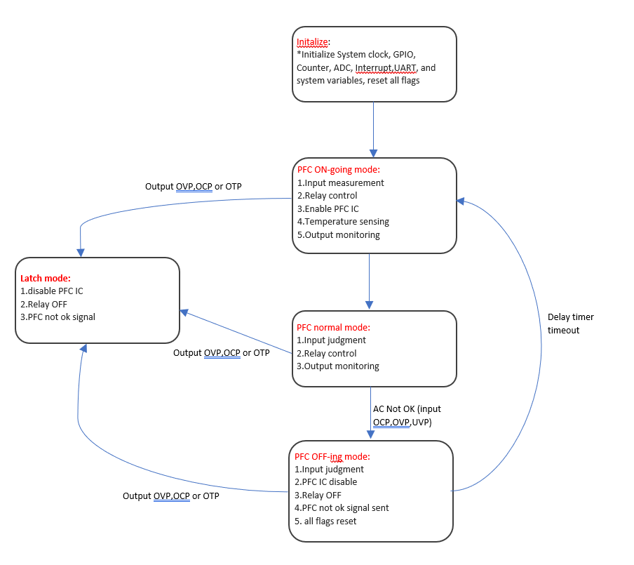

Secondary flowchart overview
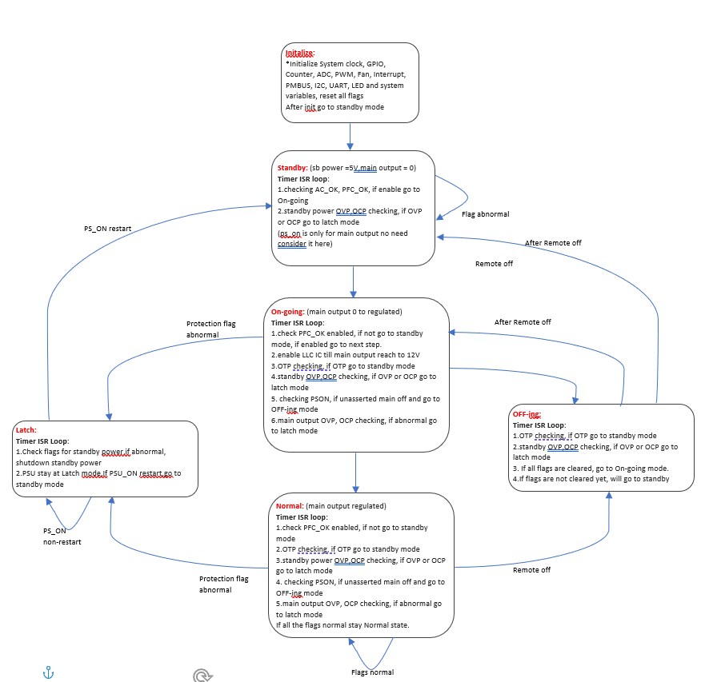

Secondary DETAIL STATUS DESCRIPTION
FW protect time and set point is described in 6. Protection,
Summary fault flag: include Fan lock, 12Vmain Output OVP, UVP, OCP, SCP, OTP and PS_ON(OFF), PS_Kill OFF, PFC_NotOK, Standby OVP, UVP, OCP, SCP.
Green: Control or PSU Status Signal PIN.
RED: Standby and Main Output Control PIN.

state_standby
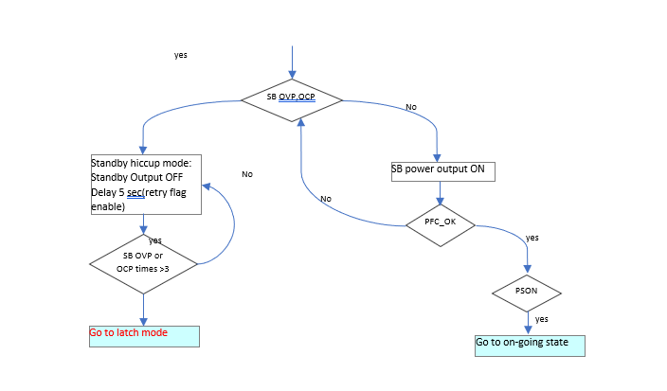

state_ONING
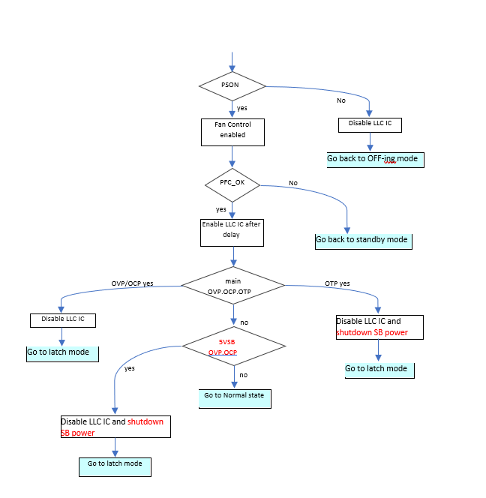

state_NORMAL
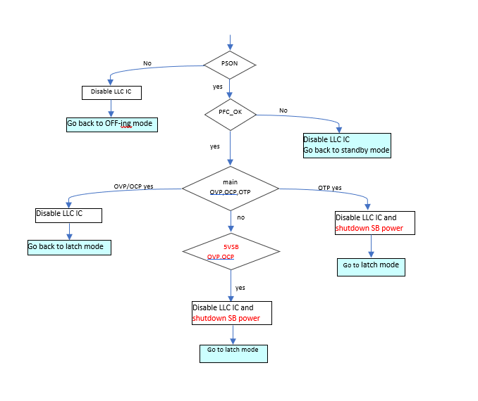

STATE_OFFING
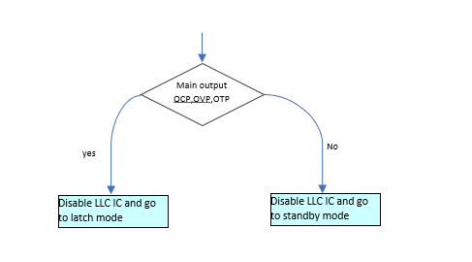

STATE_latch
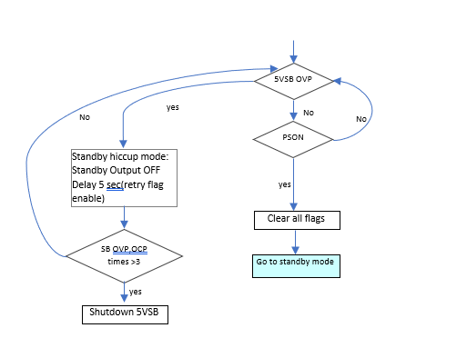

TIME SEQUENCE

Normal State Time Sequence
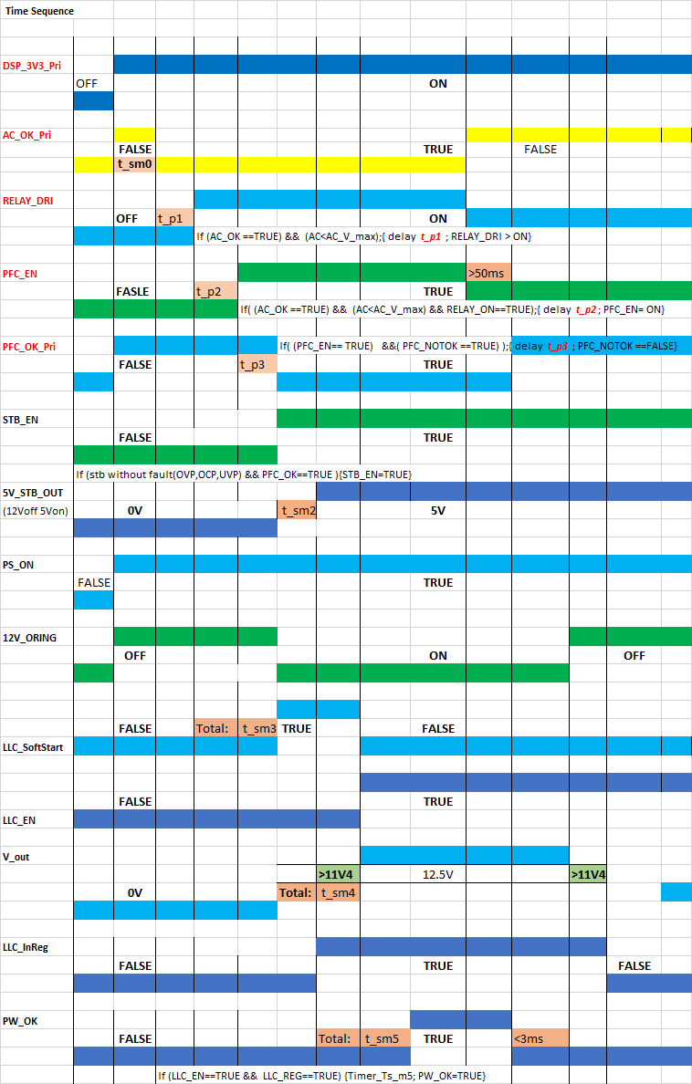

Summary fault flag: include Fan lock, 12Vmain Output OVP, UVP, OCP, SCP, OTP and PS_ON(Low), PFC_OK(High), Standby OVP, UVP, OCP, SCP.

Fault State Time Sequence -> AC_LOST

Fault State Time Sequence -> PS_ON to PS_OFF
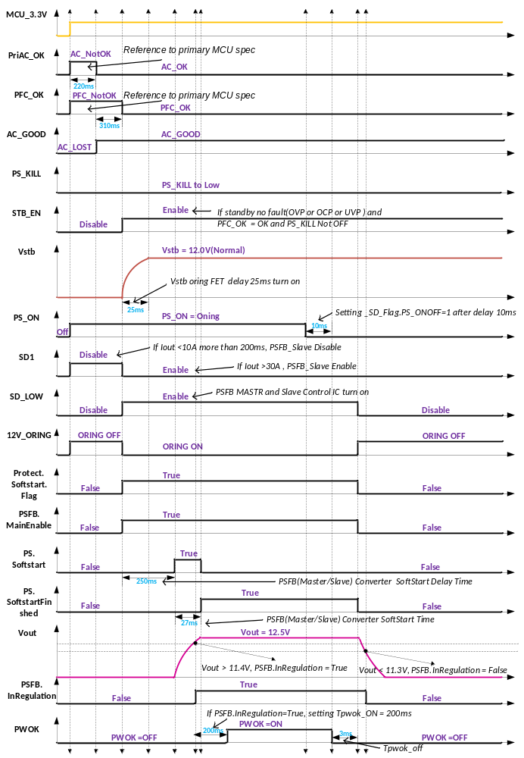

Fault State Time Sequence -> PS_OFF to PS_ON
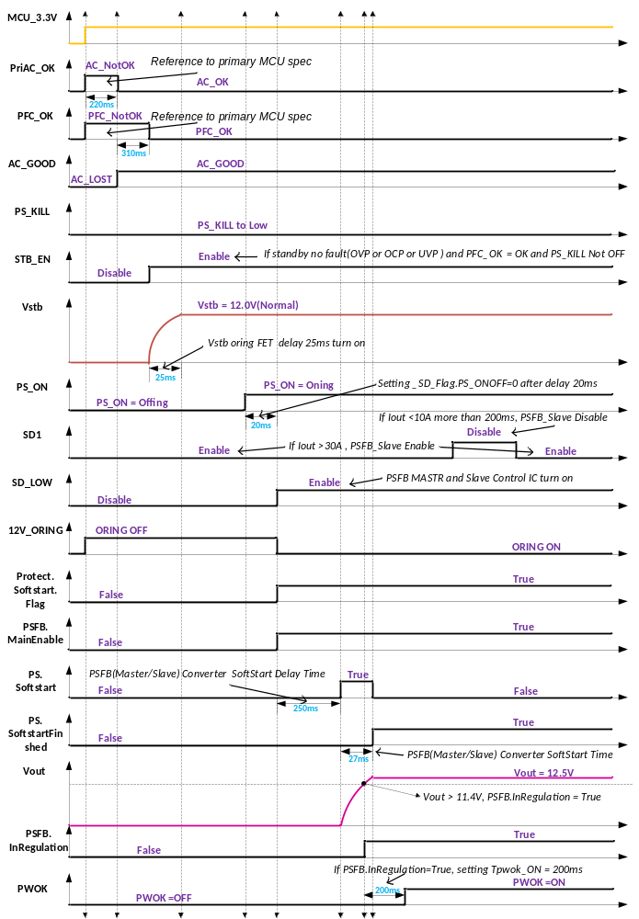

Fault State Time Sequence -> Normal to Fault ( Fault_Flag: Fan lock, OVP, UVP, OCP, SCP, OTP and STB_OVP,STB_UVP)
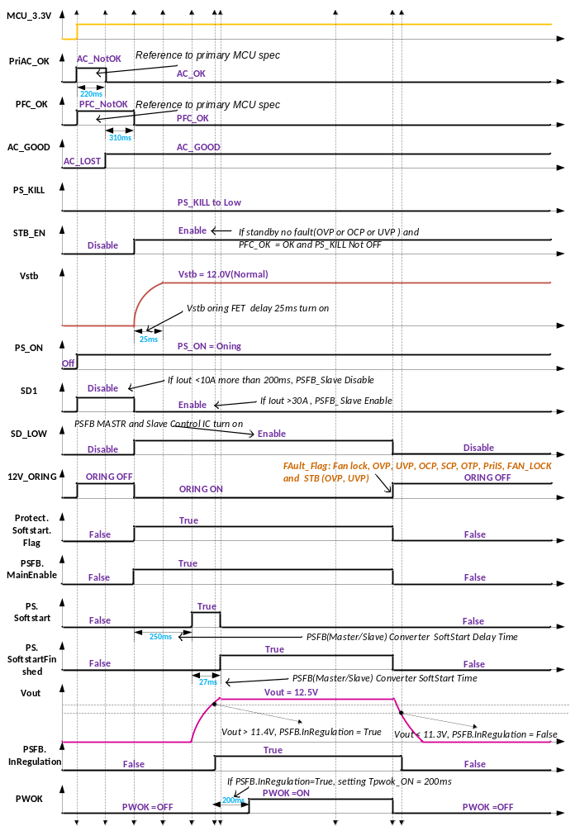

OHERT CONTROL

PMbus communication
Reference: PMBUS Spec.xlsx

RS232 communication

Setting
115200bps, N, 8, 1

Protocol

Bootloader
Optional Function (TBD)

FAN
- Table is reference from ? T_SR, Environment Temperature.
- Every Load & Temp stage has Hysteresis. Ex. 12%~15%. If lower than 12%, Fan Duty is 50%, until 15% Fan Duty change to next stage.
- If Primary temp > 75C or Secondary temp > 87C, Fan will raise Duty until full Fan Speed.
- If Primary temp < 65C and Secondary temp < 67C, Fan will decrease Duty until Fan Duty Table value( as shown in the table minimum limit ).
- When If PSU in Standby or Latch state mode, Fan Duty will set to 15% Duty.
If PSU in oning state mode, and If Primary temp > 75C or Secondary temp > 60C, Fan Duty will set to 100% Duty, otherwise Fan Duty will set to 50% Duty.

Fan Duty(Minimum)
Load Condition | <27C | 30C~37C | >40C
<12% | 50% | 50% | 75%
15%~22% | 15% | 26% | 25%
25%~32% | 30% | 30% | 30%
35%~42% | 34% | 36% | 38%
45%~52% | 36% | 47% | 58%
55%~62% | 41% | 58% | 68%
65%~72% | 50% | 70% | 78%
75%~82% | 58% | 81% | 92%
85%~92% | 69% | 91% | 100%
>=95% | 80% | 100% | 100%
Fan Duty Table

LED
LED_STATUS | DISPLAY
No AC power available | LED OFF
AC Present / +5VSB on  (Main DC Output OFF) | BLINK_GREEN(1Hz)
Power Supply ON and OK | LED_ON

FW version rule
Bootloader version | Primary Side version | PSU Model Name | Secondary Side version
2 letter | 2 letter | 2 letters | 2 letters
05 | 0E | 6A | 03

Black Box Fault Logging
When a fault condition occurs, the PSU must save certain status registers into non-volatile memory. The PSU must save a record of this data for the last five fault events. The history will be accessed via the MFR_PAGE command (E4h). If the history fills up, delete the oldest record and shift the remaining records down the queue following FIFO.
The MFR_POS_TOTAL for the Real-Time Data entry in black box fault logging (MFR_PAGE 0xFF) should not be cleared prior to PSU manufacturer shipment. All other black box data (MFR_PAGE 0x00-0xNN) should be cleared prior to PSU manufacturer shipment.

AWS Black Box Log PMBus CMD Table:
MFR_PAGE(0XE4)
MFR_PAGE | Refers to | Comments
0XFF | Real time data (default value) | When a fault condition occurs, the PSU must save certain status registers into non-volatile memory. The PSU must save a record of this data for the last five fault events. The history will be accessed via the MFR_PAGE command (E4h). If the history fills up, delete the oldest record and shift the remaining records down the queue following FIFO. Up to 17 black box events can be recorded.
0X00 | Fault history 1 (newest fault event)
0X01 | Fault history 2
0X02 | Fault history 3
0X03 | Fault history 4
0X04 | Fault history 5
0X05 ~0X10 | Option additional fault history locations
Sensors to save upon each fault event table
Command Number | Command Name | Command Number | Command Name
0x79 | STATUS_WORD | 0x8D | READ_TEMPERATURE_1 (Ambient)
0x7A | STATUS_VOUT | 0x8E | READ_TEMPERATURE_2 (Primary side)
0x7B | STATUS_IOUT | 0x8F | READ_TEMPERATURE_3 (Secondary side)
0x7C | STATUS_INPUT | 0x90 | READ_FAN_SPEED_1
0x7D | STATUS_TEMPERATURE | 0x91 | READ_FAN_SPEED_2
0x7E | STATUS_CML | 0x96 | READ_POUT
0x81 | STATUS_FANS_1_2 | 0x97 | READ_PIN
0x88 | READ_VIN | 0xD0 | MFR_FW_REVISION
0x89 | READ_IIN | 0xE5 | MFR_POS_TOTAL
0x8B | READ_VOUT | 0xE6 | MFR_POS_LAST
0x8C | READ_IOUT | 0xE7 | BMC_UNIX_TIMESTAMPS
MFR_POS_TOTAL(0XE5)
MFR_POS_TOTAL will respond with 4 bytes representing the total number of power on seconds the power supply has been turned on and delivering energy to the main output since it was manufactured in linear encoding following the PMBus specification for bit and byte order. The command is read only.
MFR_POS_LAST(0XE6)
MFR_POS_LAST will respond with 4 bytes representing the number of power on seconds the power supply has been turned on and delivering energy to the main output in linear encoding following the PMBus specification for bit and byte order. When the main output is not delivering energy, the PSU must hold the current value. The command is read only.
BMC_UNIX_TIMESTAMPS(0XE7)
BMC_UNIX_TIMESTAMP command will respond with 4 bytes representing the current reported system time from the BMC in a linear encoding following the PMBus specification for bit and byte order. The command is read/write. Writing to this command will set the current BMC time, which the PSU is then responsible for incrementing with an internal RTC. After AC power on the timestamp should default to 0 and then increment with the internal RTC.
Log fetch
1. Write Byte to CMD 0X10 ->WRITE_PROTECT Disable -> 0x00
2. Write Byte to CMD 0XE4 -> Fault history 1 (newest fault event) -> 0x00
3. Read Black Box event log -> Read fault event 1 table, EX: read cmd 0x79~7E,..etc.
4. If you want to read other older fault events, change the value from item 2, for example: Fault history 2 -> 0x01
5. Write Byte to CMD 0XE4 -> 0XFF -> Real time data (default value). Expressed as the current information, there is no black box fault event.

